**VIT-AP UNIVERSITY, ANDHRA PRADESH**

**CSE3003 – Computer Networks - Lab Sheet: 1**

**Academic year:** 2023-2024  **Branch/ Class:** B.Tech

**Semester:** Fall  **Date:**

**Faculty Name:** Prof. S. Gopikrishnan  **School:** SCOPE

**Student name: Aman Sahu Reg. no.: 22BCE7224**

**LAB 1**

1. **Design a Bus Topology network using Switches.**

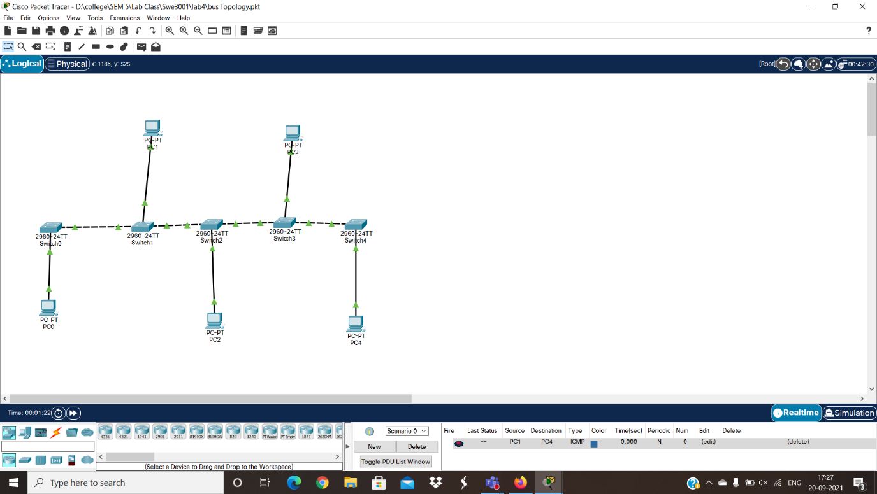

**Objectives:**

1. Design a BUS Topology using switches with PCs.
2. Verify the connectivity.

**Addressing Table:**

|  |  |  |  |
| --- | --- | --- | --- |
| **Device** | **Interface** | **IP Address** | **Subnet Mask** |
| PC0 | NIC | 192.172.16.1 | 255.255.255.0 |
| PC1 | NIC | 192.172.16.2 | 255.255.255.0 |
| PC2 | NIC | 192.172.16.3 | 255.255.255.0 |
| PC3 | NIC | 192.172.16.4 | 255.255.255.0 |
| PC4 | NIC | 192.172.16.5 | 255.255.255.0 |

**Procedure:**

* Consider 5 PC’s and 5 Switches
* Connect them as shown in figure.
* Now configure each PC as shown in table.
* Now send the packet from one end to the other node of the terminal.

**OUTPUT-**

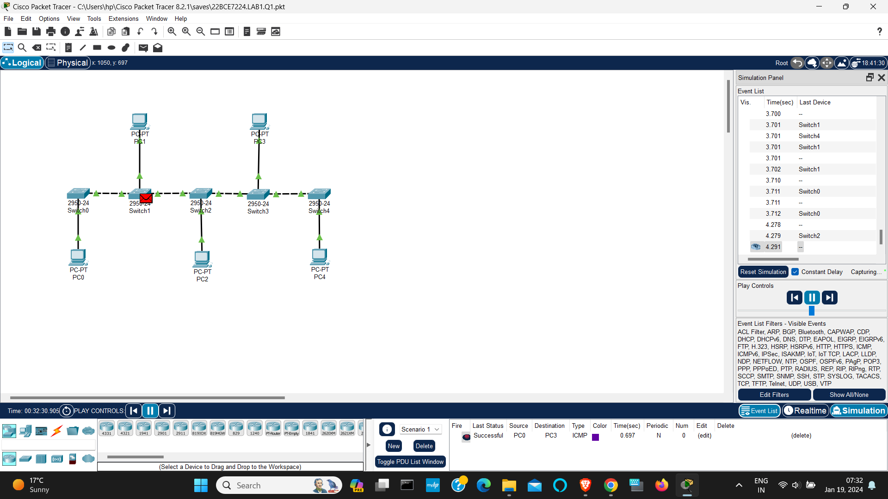

1. **Design a Mesh Topology network using Switches.**

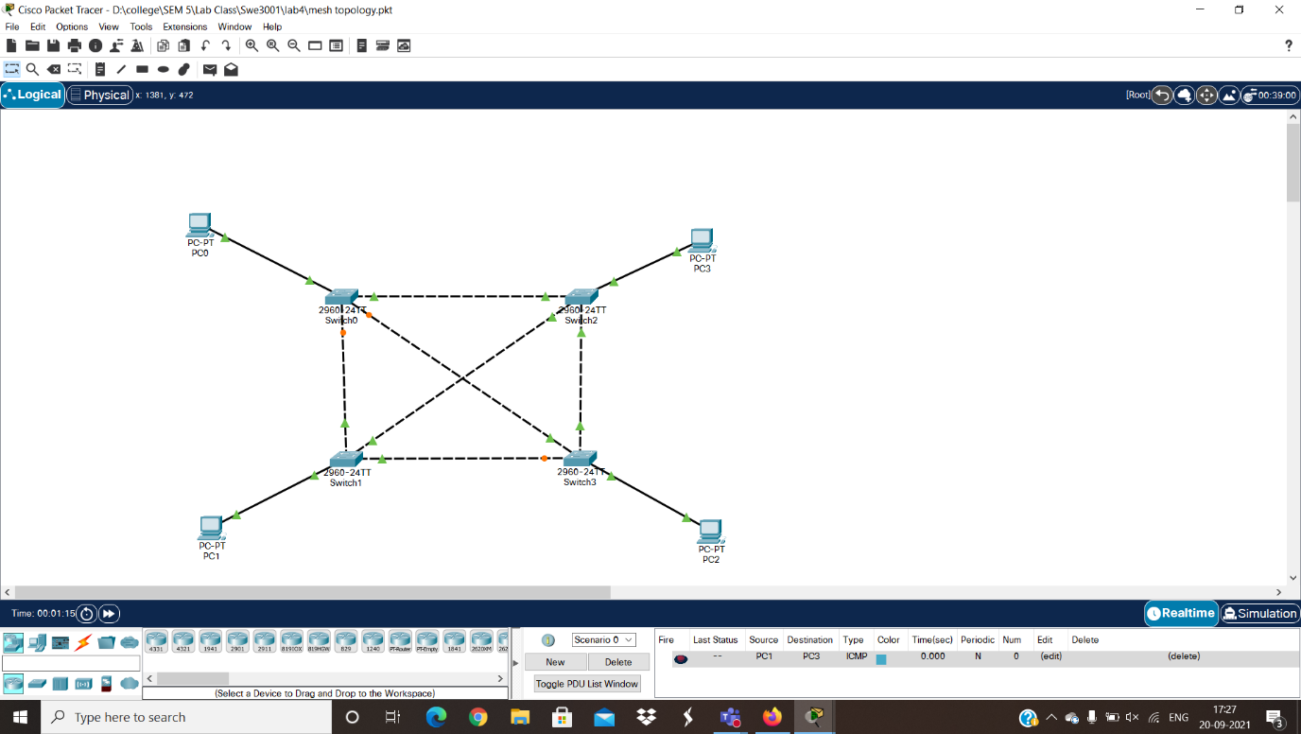

**Objectives:**

1. Design a Mesh Topology using switches with PCs.
2. Verify the connectivity.

**Addressing Table:**

|  |  |  |  |
| --- | --- | --- | --- |
| **Device** | **Interface** | **IP Address** | **Subnet Mask** |
| PC0 | NIC | 10.10.10.1 | 255.0.0.0 |
| PC1 | NIC | 10.10.10.2 | 255.0.0.0 |
| PC2 | NIC | 10.10.10.3 | 255.0.0.0 |
| PC3 | NIC | 10.10.10.4 | 255.0.0.0 |
| PC4 | NIC | 10.10.10.5 | 255.0.0.0 |

**Procedure:**

* Consider 5 PC’s and 5 Switches
* Connect them as shown in figure.
* No configure each PC as shown in addressing table.
* Now send the packet from one end to the other node of the terminal.

**OUTPUT-**

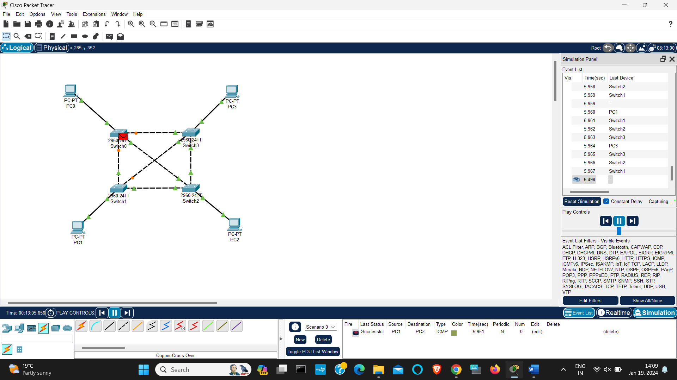

1. **Design a Ring Topology network using Switches.**

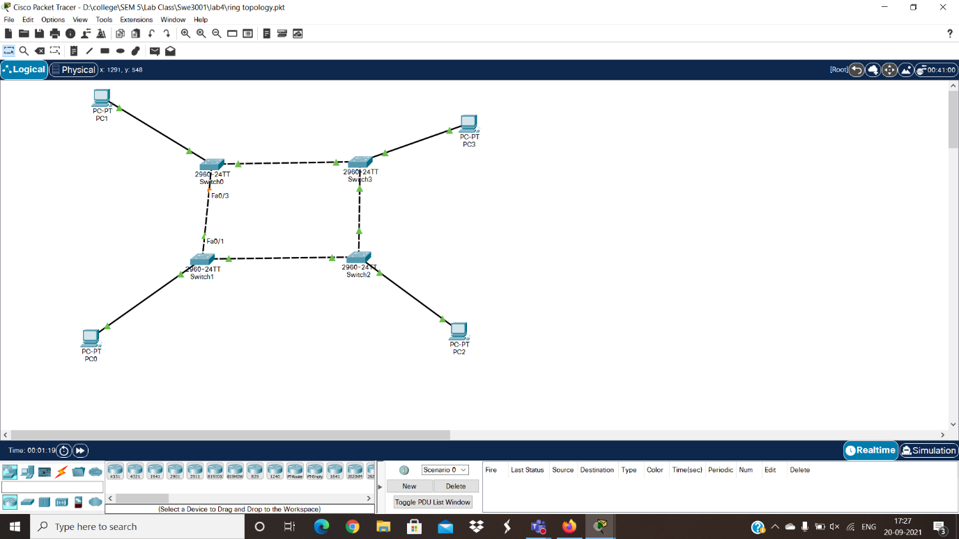

**Objectives:**

1. Design a Ring Topology using switches with PCs.
2. Verify the connectivity.

**Addressing Table:**

|  |  |  |  |
| --- | --- | --- | --- |
| **Device** | **Interface** | **IP Address** | **Subnet Mask** |
| PC0 | NIC | 10.10.10.1 | 255.0.0.0 |
| PC1 | NIC | 10.10.10.2 | 255.0.0.0 |
| PC2 | NIC | 10.10.10.3 | 255.0.0.0 |
| PC3 | NIC | 10.10.10.4 | 255.0.0.0 |

**Procedure:**

* Consider 5 PC’s and 5 Switches
* Connect them as shown in figure.
* No configure each PC as shown in addressing table.
* Now send the packet from one end to the other node of the terminal.

**OUTPUT-**

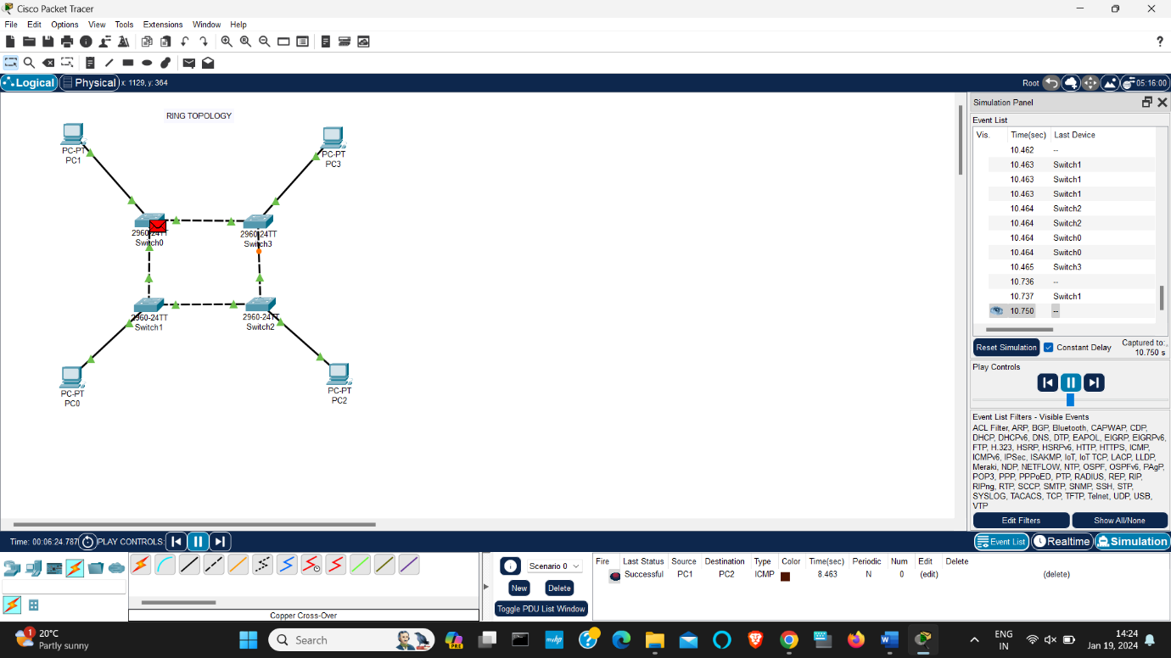

1. **Design a Tree Topology network using Switches.**

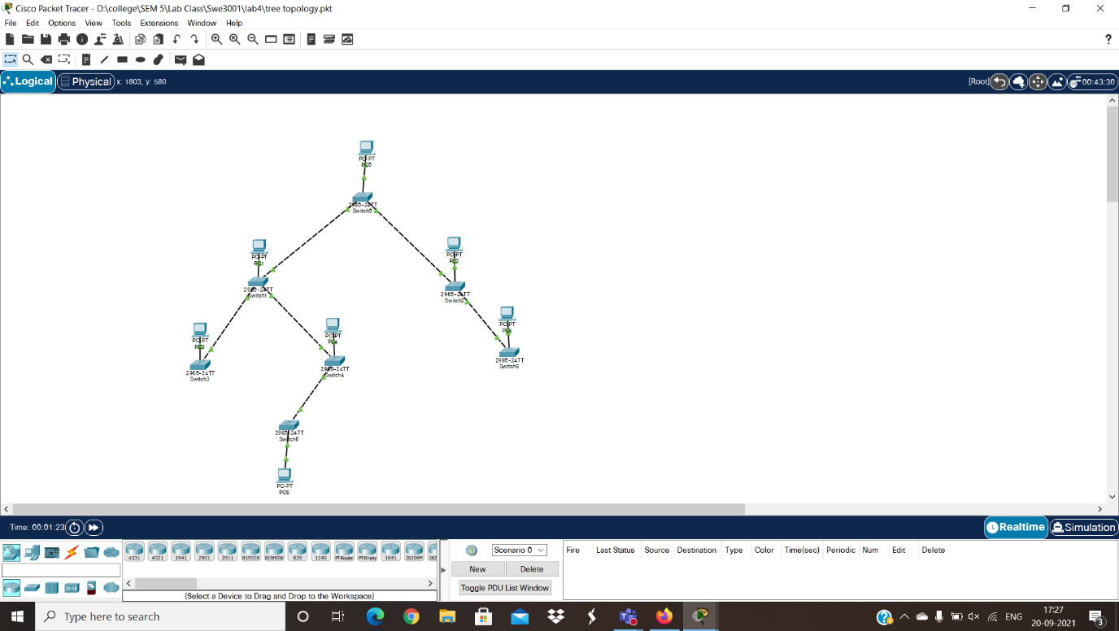

**Objectives:**

1. Design a Tree Topology using switches with PCs.
2. Verify the connectivity.

**Addressing Table:**

|  |  |  |  |
| --- | --- | --- | --- |
| **Device** | **Interface** | **IP Address** | **Subnet Mask** |
| PC0 | NIC | 10.10.10.1 | 255.0.0.0 |
| PC1 | NIC | 10.10.10.2 | 255.0.0.0 |
| PC2 | NIC | 10.10.10.3 | 255.0.0.0 |
| PC3 | NIC | 10.10.10.4 | 255.0.0.0 |
| PC4 | NIC | 10.10.10.5 | 255.0.0.0 |
| PC5 | NIC | 10.10.10.6 | 255.0.0.0 |
| PC6 | NIC | 10.10.10.7 | 255.0.0.0 |
| PC7 | NIC | 10.10.10.8 | 255.0.0.0 |

**Procedure:**

* Consider 7 PC’s and 7 Switches
* Connect them as shown in figure.
* No configure each PC as shown in addressing table.
* Now send the packet from one end to the other node of the terminal.

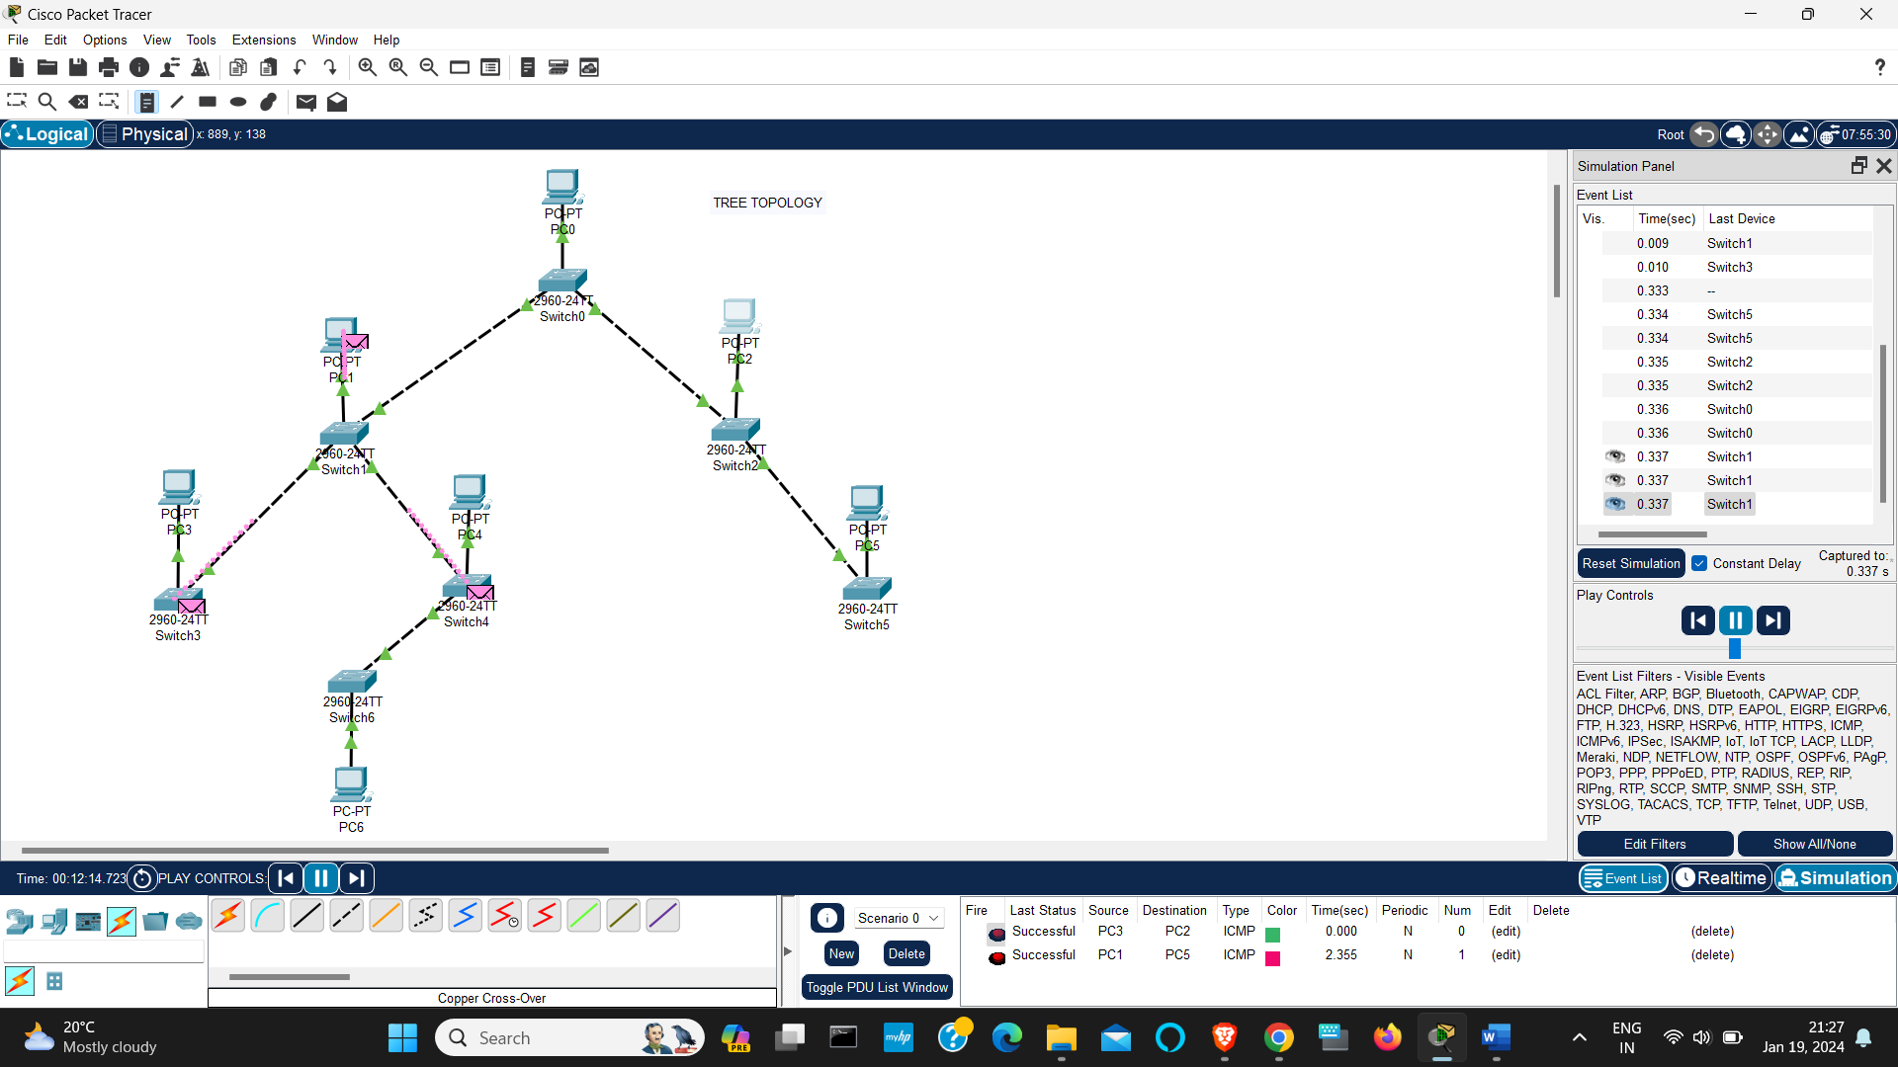**OUTPUT-**

1. **Design a Star Topology network using Switches.**

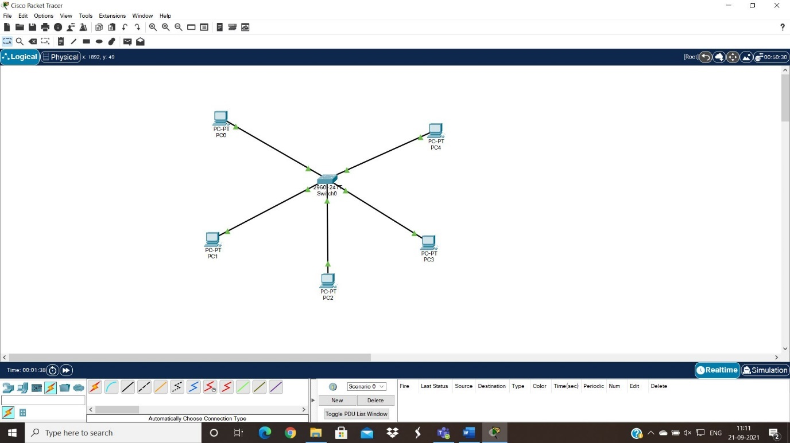

**Objectives:**

1. Design a Star Topology using switches with PCs.
2. Verify the connectivity.

**Addressing Table:**

|  |  |  |  |
| --- | --- | --- | --- |
| **Device** | **Interface** | **IP Address** | **Subnet Mask** |
| PC0 | NIC | 10.10.10.1 | 255.0.0.0 |
| PC1 | NIC | 10.10.10.2 | 255.0.0.0 |
| PC2 | NIC | 10.10.10.3 | 255.0.0.0 |
| PC3 | NIC | 10.10.10.4 | 255.0.0.0 |
| PC4 | NIC | 10.10.10.5 | 255.0.0.0 |

**Procedure:**

* Consider 5 PC’s and 1 Switches
* Connect them as shown in figure.
* No configure each PC as shown in addressing table.
* Now send the packet from one end to the other node of the terminal.

**OUTPUT-**

